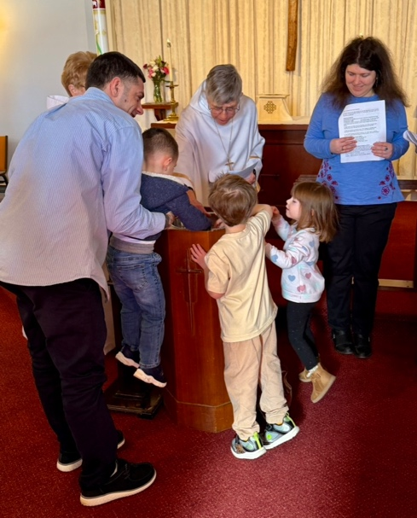
Kids helping bless the water for baptism

March 2026 Newsletter
As you can see from the photos we had fun with kids this month. We welcomed Emma Moss into the family of God. Then we had one of our “Kid’s Days”. Michele Quinn as usual came up with a day full of fun, crafts, and reflection, as the kids learned and pondered a number of the parables of Jesus. They also made some delicious bread which we had for communion! Some had to cancel at the last minute but we originally had 13 sign up! We also had a total 9 adult volunteers who gave of their time and energy (trying to keep up with the children’s boundless energy!) Thank you all for your support in this ministry!

Ongoing Christian formation is important for all of us. We grow more deeply into discipleship as we worship and work together, serve those in our communities, and engage in study and reflection. Some people had some basic Christian education when they were children but not much since then. Others never cracked open a Bible. Take advantage of not only the opportunities that are provided at St. David’s but those on the diocesan level. There is a very informative email newsletter entitled The Call that comes out every couple of weeks. You can ask to be put on the mailing list by emailing communications@nhepiscopal.org

Finally, Holy Week is coming up the last week of March. The schedule is below and you are encouraged to participate in this week where we reflect on the meaning of Jesus passion, death, and resurrection.

Be blessed as you ever grow deeper into Christ!
Carolyn

WORSHIP - Holy Week
Palm Sunday (March 29) . There will be a traditional procession with crosses and palms followed by a Dramatic Reading of the Passion with percussion. We need a lot of people to fill the many roles and read a few lines. Sign-up for a role and take a script which will be available March 22nd.
Maundy Thursday – At 6 PM on Maundy Thursday (April 2), we will have our Mediterranean style “Agape Meal” in the upper hall. Participants bring food like lentil soups, cheeses, pita bread, hummus, nuts, olives, fruit, wine and grape juice. (A sign-up sheet will be available for that too.) We enjoy the meal with a lot of laughter and fellowship. Afterwards (around 7:00) we gather in the sanctuary for an informal Eucharist. The sanctuary is then stripped of all ornamentation for Good Friday.
Good Friday –
9:00 AM starting at St. Joseph Church, anyone is welcome to join a community walk of the Stations of the Cross
Traditional Good Friday Liturgy will be held at St. David’s both at noon and at 7PM.
Easter – 9:30 AM with special music and lots of alleluias!
(If people would like to donate flowers in memory of or in thanksgiving for someone, you can send an email to Carolyn or the office with that information and put the designated offering in the plate on Sunday or have it mailed in.)

OUTREACH
Bread of Life food pantry
Laura Walta has continued to do a fantastic job encouraging food and gift card donations, and working with the Bread of Life pantry at Triumphant Cross Lutheran Church. With some of the changes going on with the homeless population mentioned above, the food donation wish list has been revised. The latest copies are always available on the table in the hallway. The pantry staff are so appreciative (and amazed) at our level of support!

Isaiah58 NH – We do not have a dedicated outreach collection for March, but the April collection will be to support our partner in ministry, Isaiah58 NH in their work to help the homeless and home insecure. Finances have been tight so they could really use some donation help. Wanted to give you all a heads up so we can give generously!

HAPPENINGS
Prayer and Care Team
Our first organizational “Prayer and Care Team” will be held on Monday March 9. The goal is to keep an eye out for those who could use both prayers and support at least at first within our congregation. We’ll be exploring both the needs and our gifts – whether it be prayers, cards, calls, food, or visits. We will keep you posted as this new ministry develops!

Fun and Fundraising Brainstorming
This Sunday (March 8) after coffee hour, anyone who would like to attend a short meeting to brainstorm possibilities for “fun and fundraising” events or activities. Come and share your ideas!

Book Group - The fourth Thursday of each month is a book discussion group to which all are welcome to attend. The meetings are held on the fourth Thursday of the month at 10 AM in the small meeting room behind the sanctuary. All are welcome!
The books for the upcoming months will be:
March 26 ~ Atmosphere by Taylor Jenkins Reid. Michele will lead the discussion.
April 23 ~ All Creatures Great and Small by James Herriot. Barbara will lead the discussion.
May 28 ~ Frankenstein by Mary Shelley. Maria will lead the discussion.
June 25 ~ The Lion Women of Tehran by Marjan Kamali. Kathryn will lead the discussion.
July 23 ~ Educated by Tara Westover. Laura will lead the discussion.
August 27 ~ The Alice Notebook by Kate Quinn. Paula will lead the discussion.

Christian Education and Formation
Men With Feet of Clay in the Hebrew Scriptures
Peter Miscall, who taught Hebrew and the Hebrew Scriptures, has begun a zoom 5 week zoom class on Wednesdays at 6PM running through April 1st. The class is looking at some of the more famous characters in the Hebrew scriptures, Moses and David, who often have been idolized as ideal heroes, when in fact they had many flaws. Contact Michele Quinn revquinn@me.com if you’d like to get on the zoom invite list.

After that series in the spring, Carolyn will lead a class in which we explore some of the Stories About Jesus and the similarities and differences found in the four gospel accounts.

The Bigger Picture – The Episcopal Church of New Hampshire
Southern Convocation
Southern Convocation had its first meeting of the year the end of February. Carolyn was re-elected as one of the conveners. The responsibilities of delegates representing the parishes were reviewed and ideas were shared for possible speakers and topics for discussion. St. David’s has three delegates: Carla Boucher, Maria Posey, and Paula Klenner.

Search Process for a New Bishop
During January the Search Committee conducted “Listening Sessions” for the purpose of getting input from both the clergy and laity about who we are as a diocese and what we are looking for in a new bishop. They will be putting together a profile and the announcing the call for those who are interested to apply. The will narrow the list to three to five people. Then during September, delegates, clergy, and others in the diocese will be able to meet the candidates in several meetings held across the state. A new bishop will be elected at a special election diocesan convention October 23 and 24.

2026 Officers and Vestry
Elaine Clark – Sr. Warden, 603-898-7576
Richard Boucher – Jr. Warden, 978-204-3115
George Ogin – Treasurer, 603-560-0805
Laura Campbell – Clerk, 603-425-3944
Maria Posey – Vestry, 603-275-2278
George Younker – Vestry, 603-247-2463
Braden Golas – Vestry, 603-362-7381
Diane Kay – Vestry, 603-425-3442

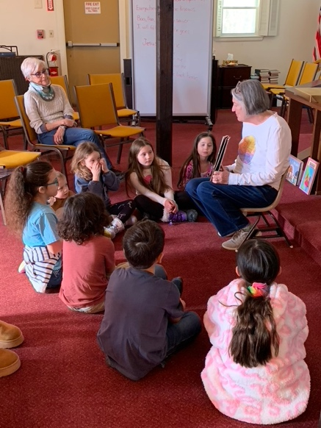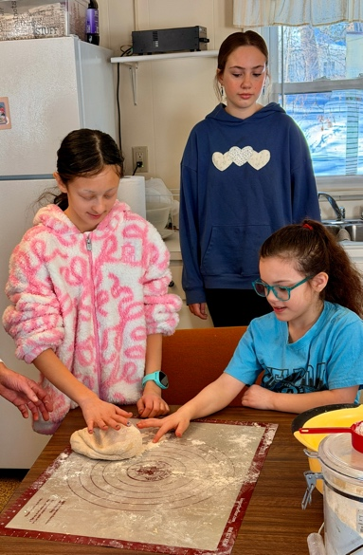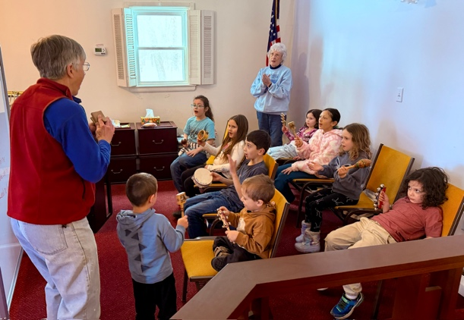

Kid’s Day on “ The Stories Jesus Told” (all about parables)

