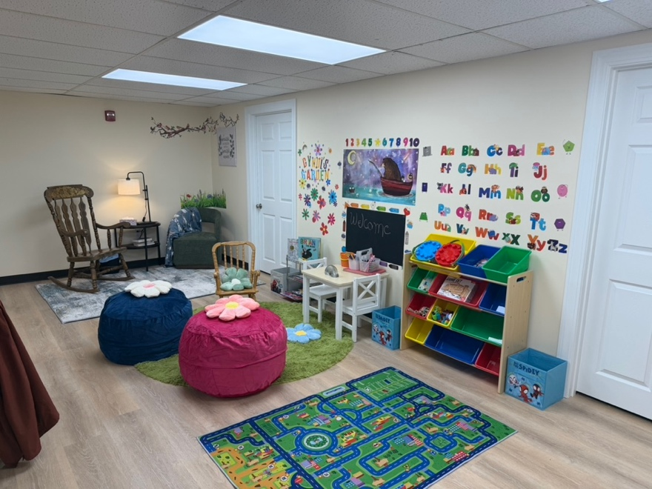
Cyndi’s Place

December 2025 Newsletter
What a wonderful occasion it was on November 20th when we dedicated and blessed “Cyndi’s Place” for the work of Isaiah 28NH. It took the work of many people. David and Karen Kagan, in another amazing act of generosity, paid to refurbish the room with new floors, walls, heating, and lights. Members of our property committee built storage closets. The Dario Foundation gave money that had not been spent on the Christmas party for Isaiah 58 families that was held last year to use to help buy office furniture and a coffee area. The vestry allocated money from our own Dave Hall Fund enabling our members to purchase lamps, pictures for the walls, a comfortable chair, and a play area for children. Isaiah 58 added some more decorations and furnishings, making for a warm comfortable space. The room is already in use, not the least this past weekend being the place where food and supplies were brought in and sorted to create and hand out baskets for Thanksgiving.

I am so proud that St. David’s is a church in which we not only seek to welcome people in and deepen our spiritual lives in Christ, but seeks to reach out to those in need in our community with compassion and help!

On a much sadder note, we lost another beloved member of our faith community, Kevin Smith. He graced us with his gift of music and was instrumental in helping to carry us through the difficult years of Covid with his technical knowledge helping to enable us all to worship together. Visiting hours will be Monday December 1 from 3:30-7:30 at St. David’s with the funeral the following morning also at the church at 11AM. All are welcome to attend and also to come to a meal afterwards at the Irish Cottage in Methuen.

Peace and all good,
Carolyn
OUTREACH
Episcopal Relief and Development – Our outreach collection for December is ERD. It serves to bring together the generosity of Episcopalians and others with the needs of the world. It faithfully administers the funds that it receives from the church to provide relief in times of disaster and promotes sustainable development by identifying and addressing the root causes of suffering in the United States and across the world.

ChIPs (Children of Incarcerated Persons)
A group of members will be doing to the Men’s State Prison in Concord on Tuesday Dec. 2nd to wrap the books and toys you donated for the men to give to their children at an annual Christmas party.

Food Pantry Donations
The food baskets continue to be filled with food and household supplies every week! Additionally people have been donating hundreds of dollars worth of gift cards. A big shout out to Laura Walta who has been doing a wonderful job re-energizing this ministry!

HAPPENINGS
Salem Christmas Parade – this Sunday November 30th, members of the church will once again be providing hot chocolate, coffee, and cookies for the residents of Salem from 12:30-2:30 as they watch the parade. People are always so grateful for food and drink to keep warm! You can drop off baked cookies to sell in the small coffee room Saturday or Sunday morning. Thank you!

Book Group - The fourth Thursday of each month is a book discussion group to which all are welcome to attend. Due to the holidays, the next and last meeting of 2025 will be Thursday December 4 at 10AM in the small coffee room. The book to be discussed will be: How We Learn to Be Brave by Mariann Edgar Budde.
Interested in what is coming up after that?
January 22 The Cat God Sent by Jim Krausàè
February 26 Wide Sargasso Sea by Jean Rhys

Kid’s Day – Have you ever wondered how the church tells time? Or more importantly why we tell time the way we do in the church? On Saturday December 13 from 9:30-2:30 our children will learn all about the beginning of Advent, the getting ready time and Christmas…just what kind of baby was born so long ago and how we celebrate that. Godly Play stories, crafts, grilled cheese and tomato soup (by popular kid request!) and don’t forget – the hoola hoop game. Our children will be introduced to the liturgical calendar, the difference in the stories of the nativity ad we’ll explore what it all means for us today!
PS – for the grown ups – if you don’t know about the liturgical calendar, we’ll have one posted in the small room off the sanctuary after December 13!

Membership Photos – We all know how difficult it can be to remember people’s names. This is especially difficult for those who are new to St. David’s. One way of helping people to get to know others is by looking the names and photos of those who attend our church. Michelle Quinn has taken over the task of updating the pictures on the wall and will also work on a directory. So when she asks to take your photo – say yes, and smile! It is one way we welcome people to the church!
PS – you can also email a photo and your name to Michelle at revquinn@me.com

WORSHIP
Setting up for Christmas
Plan to stay after church on Sunday December 21 to decorate the sanctuary for Christmas eve. The more the merrier!

Christmas Eve Services
- Christmas Eve: music will begin around 7:20 with congregational singing of carols. Then the Feast of the Nativity will begin at 7:30.
- Christmas morning, Thursday Dec. 25 at 9:30 AM, there will be a small informal service of Holy Eucharist without music.
- On Sunday December 28 at 9:30 AM instead of our usual practice of having a service of Christmas Lessons and Carols, we will sing our favorite Christmas carols interspersed with readings as a part of an informal and fun congregational pageant!

PROPERTY
- Thanks to all who helped out with our fall clean up.
- The roof over the upper hall was replaced.
- Some electrical work was done to eliminate the need for extension cords.

SCRIP
Scrip is a program where people can order through the church a wide variety of gift cards from stores and restaurants. They can be used for everyday purchases or to give as gifts for the holidays. You write a check made out to St. David’s for the full value of the gift cards and submit that along with your order sheet. You usually get your cards within a couple of weeks. The church also benefits, getting anywhere from 3-10% of the value of your gift card. The vestry decides how to best use the funds from the scrip program – sometimes paying for a special project, an outreach effort, or for operational costs. Order forms are in the foyer and the last date before Christmas to submit an order will be November 30.

STEWARDSHIP
Thank you for all your pledges to support the life and ministry of St. David’s in 2026!
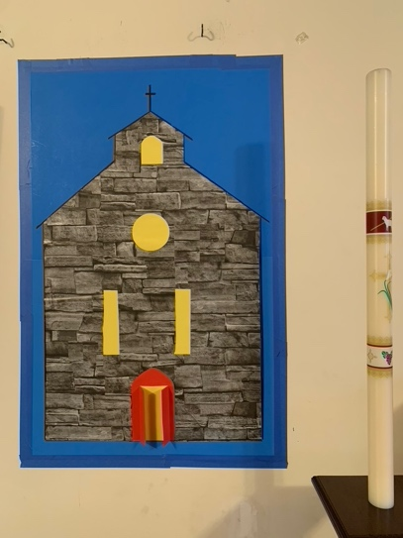

2025 Officers and Vestry

Elaine Clark – Sr. Warden, 603-898-7576
Richard Boucher – Jr. Warden, 978-204-3115
George Ogin – Treasurer, 603-560-0805
Laura Campbell – Clerk, 603-425-3944 Maria Posey – Vestry, 603-275-2278
Brandon Sousa – Vestry, 603-401-8892
Braden Golas – Vestry, 603-362-7381
Miriam Acevedo – Vestry, 603-489-3731

