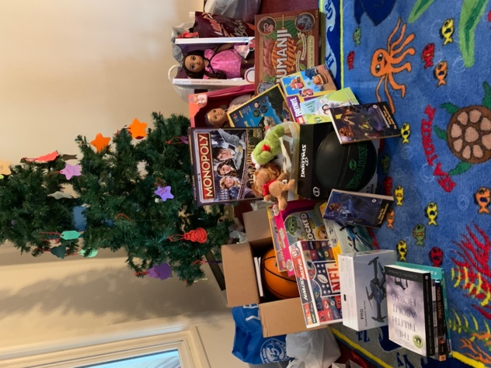
ChIPS 2025

November 2025 Newsletter
As I was walking Woody through the Field of Dreams this week (I’m dog sitting again), a reporter from Salem Life stopped me. She is going around town asking people what they are grateful for. I told her about my “gratitude jar” which I started three years ago during our stewardship campaign. I found out that she too has a gratitude practice where she writes down three things she is grateful every day. I told her I was the priest here at St. David’s and how I am grateful for all of you.

This Sunday we celebrate All Saints, remembering the saints who in some way touched our lives. Most of us will be remembering by name family and close friends. But we also are giving thanks for being surrounded and upheld by (as it says in one of our Eucharistic prayers) “the heavenly chorus, with prophets, apostles, and martyrs, and with all those in every generation who have looked to you in hope.” We are here because of the faith of those who have gone before us. We stand with the faith and support of those around us. And who we are and what we do will shape those who come after us.

We are now one week into our 4 week short and sweet stewardship campaign “Building a Living Church” with the image of us being like living stones. Here at St. David’s, God is creating a community of people in whom God lives and through whom God works to heal our broken world. Last week we looked at our past. As we browsed through old photo albums, George Younker gave a wonderful talk about our church’s founding. This Sunday (Nov. 1), we’ll be looking at the present, the great things God is doing and the challenges we face. Then on Nov. 7 we’ll share dreams of our future. Where is God calling us? How can we begin working towards that. The final Sunday we’ll celebrate with some cake (and if people want to talk more, we will)!

So as you continue to pray about making a pledge to support the church and turn in your cards, please stay after church for these discussions. After all, you can’t build a church with one stone. We need each other and God needs us.
Peace and all good,
Carolyn

OUTREACH
ChIPs (Children of Incarcerated Persons)
Once again you all filled the space underneath our Christmas tree with books and toys that those who are in prison can give to their children for Christmas. Each year the volunteers collecting those gifts at diocesan convention are blown away by how much our little parish provides. The inmates thank you for remember them and helping them maintain family bonds during their time of separation.

We also have a group of members going to the prison Tuesday Dec. 2nd to wrap the gifts. If you want to join them, the background check forms and documents have to be filled out, signed and turned into Carolyn no later than Wednesday November 5. Blank ones and instructions are on the hallway table.

Food Pantry Donations
The food baskets continue to be filled with food and household supplies every week! Additionally $275 worth of grocery gift cards were donated! As I am writing this, the SNAP benefits (food stamps) will not be renewed November 1 if the federal shut-down continues. Some families may need to choose between food, rent, and other bills. We will see what happens, but the pantries may need extra support during November. Laura Walta has been providing us with regularly updated shopping lists of the current pantry needs. You can find them on the table in the foyer so you take with you when you go to the grocery store. Thank you all so much!!

Lazarus House
$550 was donated towards Lazarus House’s “Walk for Hope”. Thank you!

HAPPENINGS
Fall Clean Up Day – People are welcome to come to church in their grubbies Sunday Nov. 16 and stay to help with the fall clean up chores. Not a lot needs to be done but you can find the list of tasks posted in the upper hall bulletin board. If prefer to take a job but do it on another day, you’re welcome to do so. Just write you name by the task on the list.

Dedication and Blessing of Cyndi’s Place – It has been a long time coming, but the room below the Sanctuary will be dedicated on Thursday November 20th at 6:30 PM. This room will be used by Isaiah 58nh as a family friendly place for case managers to meet with clients for intakes and conferences, offer educational programs, and store supplies for the 40 or so people currently living in tents and cars in Salem. Everyone is welcome to attend!

Salem Holiday Parade – The annual Christmas parade will be on Sunday November 30 from 1-3. St. David’s always sells cookies, hot chocolate, and coffee for the parade watchers. So we’ll be asking people to bake some cookies. We’ll put up a tent on the lawn around 12:30. Usually we then jump up and down to keep warm, cheering on those in the parade and thinking about getting an old fire truck with our name on the side that we can decorate and join in the parade. (Long-standing joke!)

Book Group
The fourth Thursday of each month is a book discussion group to which all are welcome to attend. Due to the holidays, the next and last meeting of 2025 will be Thursday December 4 at 10AM in the small coffee room. The book to be discussed will be: How We Learn to Be Brave by Mariann Edgar Budde.
Interested in what is coming up after that?
January 22 The Cat God Sent by Jim Krausàè
February 26 Wide Sargasso Sea by Jean Rhys
STEWARDSHIP – Building God’s Living Church 
Our annual short and sweet financial stewardship campaign kicked off Sunday Oct. 26. I’ve already written a bit about it in my opening letter. As with a lot of our campaigns, we use the time to reflect on a certain topic or about what’s happening in the church rather than talking about giving money. But the reality is that we need money to do what we do. So let me reiterate here the importance of pledging. It is not only a concrete way to say, “Thank you God!”, but it is what enables us to both plan for and carry out the life and ministries of St. David’s. Some of you can only give a little, some a lot. And if your life changes resulting in what you had planned to give, that’s ok. It’s life! But please know that your prayers, faith, work, and generosity is what makes St. David’s possible. Let’s keep it going!

COFFEE HOUR REFRESHMENTS and SANCTUARY FLOWERS
Thanks to all of you who provide some refreshments after church. This is an important ministry of hospitality that makes people feel welcome and brings us all together.

And thanks to all of you who have been providing flowers for the altar. Know that during Advent (November 30 – December 21) flowers will not be needed since we’ll have an arrangement of greens to reflect the season, and from Christmas through at least Epiphany (which we’ll be celebrating Sunday January 4) we’ll have poinsettias. Mid-December we will be collecting donations for the poinsettias for a festive Christmas. Thank you for making our church warm, welcome, and beautiful!

PROPERTY
- Bob McGilvary is working on filling in the gully by the front fence and preventing further erosion.
- The upper hall roof will be replaced soon.

Election of a new bishop
Many of you may not be familiar with what happens when a diocesan bishop resigns. A formal process begins lasting usually a total of 18 months. Earlier this fall, Bishop Rob announced his coming resignation. Since then a slate of a combination of lay and clergy have been selected to serve on the Search Committee (job is primarily to find and select a final slate of candidates) and on the Transition Committee (oversees the election process and transition that follows). The Search Committee will be developing a diocesan profile and accepting nominations and applications from those who are interested in being the next bishop of New Hampshire during March and April of 2026. The committee then narrows down the number of potential candidates to usually 3-5 persons. A series of “Meet and Greet” sessions will be held throughout the diocese during September and October so delegates can get to know them and ask questions. October 23-24, 2026 will be our annual Diocesan Convention during which parish delegates and clergy elect the new bishop of New Hampshire. That person will be ordained on March 6, 2027. So 2026 is going to be a very exciting year in the diocese! Those elected to serve as delegates for St. David’s at our annual meeting this January will be among those choosing our new bishop. We have been so blessed by Rob Hirschfeld! Pray that Holy Spirit will guide us in finding the right person as we move forward.

And as a heads-up, Bishop Rob will be trying to visit all of the parishes in 2026. So he will be visiting us for the last time on Sunday June 21.

SCRIP
Scrip is a program where people can order through the church a wide variety of gift cards from stores and restaurants. They can be used for everyday purchases or to give as gifts for the holidays. You write a check made out to St. David’s for the full value of the gift cards and submit that along with your order sheet. You usually get your cards within a couple of weeks. The church also benefits, getting anywhere from 3-10% of the value of your gift card. The vestry decides how to best use the funds from the scrip program – sometimes paying for a special project, an outreach effort, or for operational costs. Order forms are in the foyer and the last date before Christmas to submit an order will be November 30.

2025 Officers and Vestry

Elaine Clark – Sr. Warden, 603-898-7576
Richard Boucher – Jr. Warden, 978-204-3115
George Ogin – Treasurer, 603-560-0805
Laura Campbell – Clerk, 603-425-3944 Maria Posey – Vestry, 603-275-2278
Brandon Sousa – Vestry, 603-401-8892
Braden Golas – Vestry, 603-362-7381
Miriam Acevedo – Vestry, 603-489-3731

