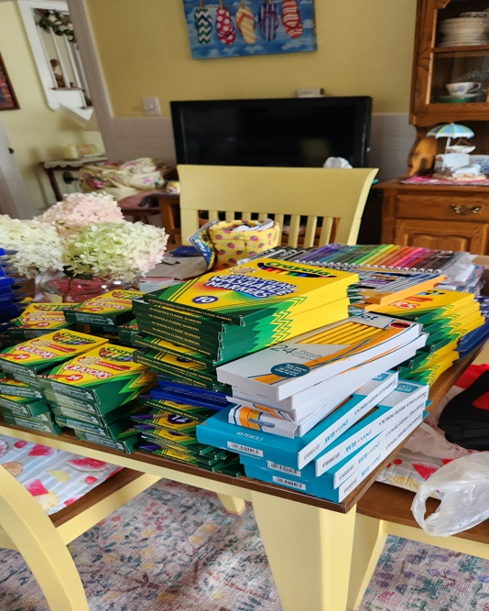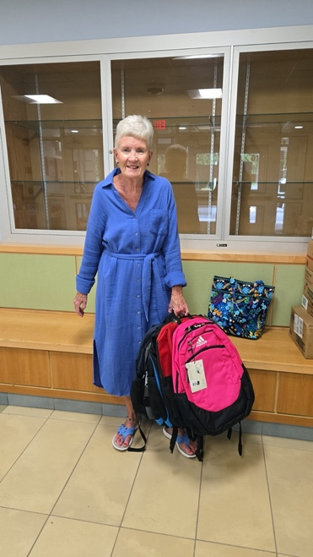
School supplies collection

September 2025 Newsletter
From the rector: My heart is breaking this week, and many of yours, as we heard about another mass shooting, this time taking place in a church where children were worshiping. Two young kids were killed,17 wounded, and the shooter killed their self. Mayor Jacob Frey, grief stricken and angry said to reporters, “Don’t say thoughts and prayers.” But I’d humbly like to offer a few of my thoughts and my prayers.

Frey meant of course that he wanted to see concrete actions to bring about change. We know at least some things that can be done to try to minimize these tragedies. We are familiar with them because the actions have been proposed many times before:
- Expanding training to those in leadership, social support positions, peer groups, parents, and anyone else who is interested, the skills to recognize warning signs that someone may be a danger to themselves or others and what to do.
- Having affordable, accessible, and quick mental health care for those individuals before they hurt themselves and/or others.
- Thorough mandatory criminal and mental background checks for those purchasing guns and closing all loopholes.
- I believe that those on both sides of the issue of guns can respectfully come together to find common ground and work to implement significant change. I believe that who have guns for hunting, safety, and sport don’t want innocent victims to be shot any more than anyone else. Both groups know that while anything can be used to kill someone, guns are specifically designed for the purpose of killing. While we cannot prevent all incidents of gun violence, the risk of many people being killed or wounded before trained police can arrive can at least reduced if we were to ban weapons made with the capacity to fire from a distance large numbers of bullets in rapid succession that have the ability to pierce the stained glass windows of a church killing children. If there is the will, there is a way!
But that brings me to Frey’s comment about prayer. Prayer is needed. Not because prayer will motivate God to cast a protective bubble around innocent people so they and we can suffer no harm. Sometimes I wish that were the case! But God has given us not just us as individuals but as communities the free will to choose to destroy or cultivate life. We pray, so that we in our hearts, homes, and as a nation turn from violence to peace, from hate to love, from vengeance to mercy, from isolation to community, from fear to hope, from death to life.

God, through the power of prayer can change us. Have hope in the power of God’s Spirit and keep praying!
Peace and all good,
Carolyn

OUTREACH
School supplies August outreach donation
Diane Kay brought bags and bags of supplies to both the Lancaster and Soule Elementary schools. The principals of both places came out and were thrilled. At Lancaster she was told, “I knew you wouldn’t fail me!” And at Soule, the principal came out, helped bring the supplies in, and then said, “Oh my God! I am so grateful, so grateful. Can I give you a hug? You made my day. This is wonderful.” Good work folks! This is one way we show the love of God for our kids and their teachers. Diane is going to continue to reach out to them and offer our help in any way that we can.

September outreach: Hike for Hope for Lazarus House Ministries
Every year St. David’s supports Denise Labreque and Micki LaBlanc as they participate in one of the major fundraisers for Lazarus House. Lazarus House provides housing, food, clothes and services to the poorest of the poor in the greater Lawrence area. Although the hike will be on Sept. 13th, we will collect donations on behalf of St. David’s thoughout the month. Your generosity is deeply appreciated!

October outreach: Chips
During October St. David’s will again be collecting Christmas gifts of books and toys for children of incarcerated parents. This is a diocesan wide effort and our delegates will be bringing our gifts to Diocesan Convention on Saturday Nov. 1. There are numerous restrictions as to the gifts which will be posted in the foyer hall bulletin board as well as the one in the upper hall. But we’ll talk more about the details of this program later in September.

CRAFT FAIR: Sept. 20 !
We are now in full gear!
- Signs are in the upper hall that can be posted on private property. They cannot be put on public property till Sept. 6. If you take a sign, note that on the sheet on the foyer table.
- This is an “All hands on deck!” event where we need everyone’s help. Sign up sheets are in the foyer for helping with set-up and take-down, the cookie walk, the café, and the raffle. There is something to do for everyone!
- If you made or are making a raffle basket, please bring it in on Sunday. Likewise it is the final call to bring in prizes or gift certificates from businesses and restaurants.
- Right now we have around 25-30 crafters. We can take up to 40. Someone informed me today that crafters have booths set up on Sundays after 10 am at both Tuscan Village and near Dick’s Sporting Goods at Rockingham mall for at least two hours. If you’d like to swing by and collect crafter’s business cards and possibly talk to them about our fair, Marion can send out an invitation for them to apply.
- It will be soon time to start baking cookies for the cookie walk. It is a huge draw for shoppers who love to pick out a variety of cookies. The church has some freezer space in a chest freezer in the small coffee room if you don’t have space at home.

COFFEE HOUR REFRESHMENTS
A new sign-up sheet to take a Sunday to provide some refreshments after church on the board above the coffee maker in the upper hall. This is an important ministry of hospitality that makes people feel welcome and brings us all together. Thank you!

SANCTUARY FLOWERS
Wanting a smell of autumn in the church? We are continuing to experiment with fresh flowers on Sundays. So here’s how it works:
There’s a sign-up sheet in the front hallway. Pick a date and write your name and what they are for…. Birthday, anniversary, grateful, memory etc. Then the fun part! Either gather two bouquets from your garden or purchase two from the grocery store. No need to be fancy – Jesus found the lilies of the field to be awesome! There will be available two plain glass vases to put them in - 3 sizes to choose from.
It’s really quite simple …. Questions? Ask Lana or Michele

PASTORAL CARE TEAM
Do you enjoy sending out greeting cards, making a phone call, paying someone a visit or delivering them a batch of cookies? Would you like to be trained as an Eucharistic visitor bringing people communion? Any one or all of these are needed. Carolyn would like to organize a care team to help us better care for one another. And who knows? You will only do what you enjoy and are comfortable doing. Speak with Carolyn if you are interested.

PROPERTY
Isaiah 58nh was not able to begin to furnish the renovated room downstairs. They plan to do so in September. We’ll keep you posted at when it will be dedicated.

HAPPENINGS
Zoom Bible Study: Ongoing weekly zoom Bible study at 10 AM on Monday mornings.

Meditation group: Mondays at 2:25. This is a drop-in group during which we have an initial check in to see what is happening with each other followed by 15-20 minutes of silent mediation together. All are welcome.

Book Club – the group meets on the 4th Thursday at 10 am. Everyone is always welcome! This month’s book for August 28 is The Only Woman in the Room by Kristin Harmel.
Interested in what is coming up after that? More information contact Laura Campbell at lauricemm@comcast.net or 603-425-3944
September 25 The Forest of Vanishing Stars by Marie Benedict
October 23 The Beekeepers Apprentice by Laurie R. King
November/December (TBD) How We Learn To be Brave by Mariann Edgar Budde
January 22 The Cat God Sent by Jim Krausàè
February 26 Wide Sargasso Sea by Jean Rhys

TRANSITIONS: Welcome back Anita Hill! A warm welcome also to the many people who have recently been visiting and worshiping with us!

2025 Officers and Vestry
Elaine Clark – Sr. Warden, 603-898-7576
Richard Boucher – Jr. Warden, 978-204-3115
George Ogin – Treasurer, 603-560-0805
Laura Campbell – Clerk, 603-425-3944
Maria Posey – Vestry, 603-275-2278
Brandon Sousa – Vestry, 603-401-8892
Braden Golas – Vestry, 603-362-7381
Miriam Acevedo – Vestry, 603-489-3731

Church phone: 603-893-0342
Web site: stdavidsalemnh.org

